Supplementary Table S1: Changes of clinical, laboratory and imaging parameters in all included patients (total study population) (n=31)

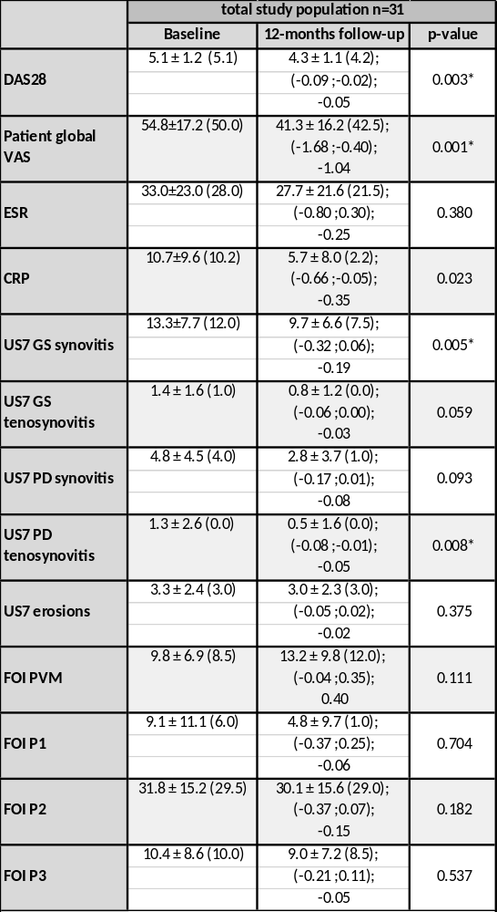
Table S1: Changes of clinical, laboratory, US and FOI parameter over 12 months after RTX therapy in total study population: mean ± standard deviation (median); 95% confidence interval (12 months column); beta as change after 12 months (12 months column); *p-value for significant change over time; DAS28 = Disease Activity Score 28; VAS = Visual analogue scale (0-100mm); CRP = C-reactive protein (mg/l); ESR = Erythrocyte sedimentation rate (mm/hour); US7 = Ultrasound seven joint score; GS = Greyscale; PD = power Doppler; FOI = Fluorescence Optical Imaging; PVM = Prima Vista Mode; P1,2,3 = FOI phases 1,2,3

Supplementary Figure S2: Course of significant parameter decrease within follow-up in total population (n=31)

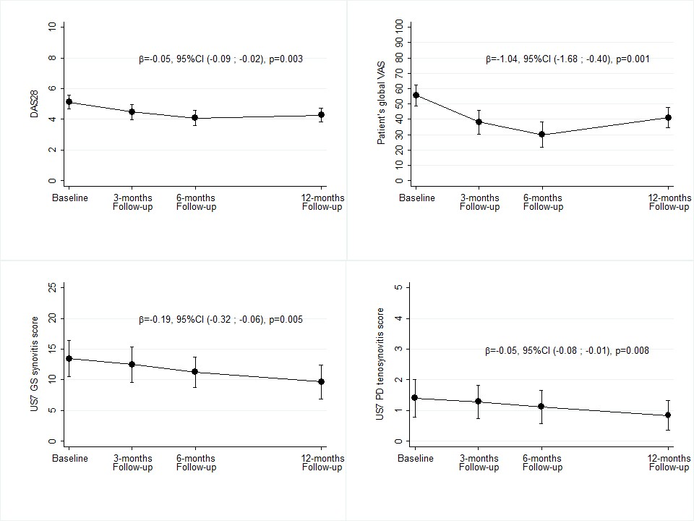

Figure S2: Course of significant parameter decrease within follow-up in total population (n=31): mean ± standard deviation (median): 95% confidence interval (12 months column); beta as change ; p-value for significant change over time; DAS28 = Disease Activity Score 28; VAS = Visual analogue scale (0-100mm); US7 = Ultrasound seven joint score; GS = Greyscale; PD = power Doppler.

